Julian Popovski-Jones, James Chang, and Dylan Hoi at University College London have been working with Avanade and Microsoft on a project to unmask “black box” AI algorithms.

The primary goal of their project is to create a web-based application for explaining how a machine learning model makes certain predictions. The application would enable anyone to upload machine learning models and datasets and receive concise explanations.

The challenge to realize this goal is enormous. While ideas for an online AI explainer are not rare, there is no actual related product, meaning the team has no references to review.

Subsequently, the team faced another issue: none of the team members have extensive knowledge in the field of AI technology, meaning the team would have to start from researching and learning the fundamentals of machine learning.

Aside from these issues, there are still countless challenges ahead - which explanation module should they choose for their product? How to host the web-based application? How much is it going to cost to maintain this application? Nevertheless, the team remained confident that they will be able to achieve all of their primary goals.

The team started by reviewing two products related to explainable AI to come up with a solution: Microsoft Azure’s machine learning explainer, and explAIner.

explAIner is a framework for explainable AI and Interactive machine learning that users can use to incorporate explainer with trained models. Though an AI explainer service itself, explAIner provided a good picture of how machine learning models work and connect with explainer tools.

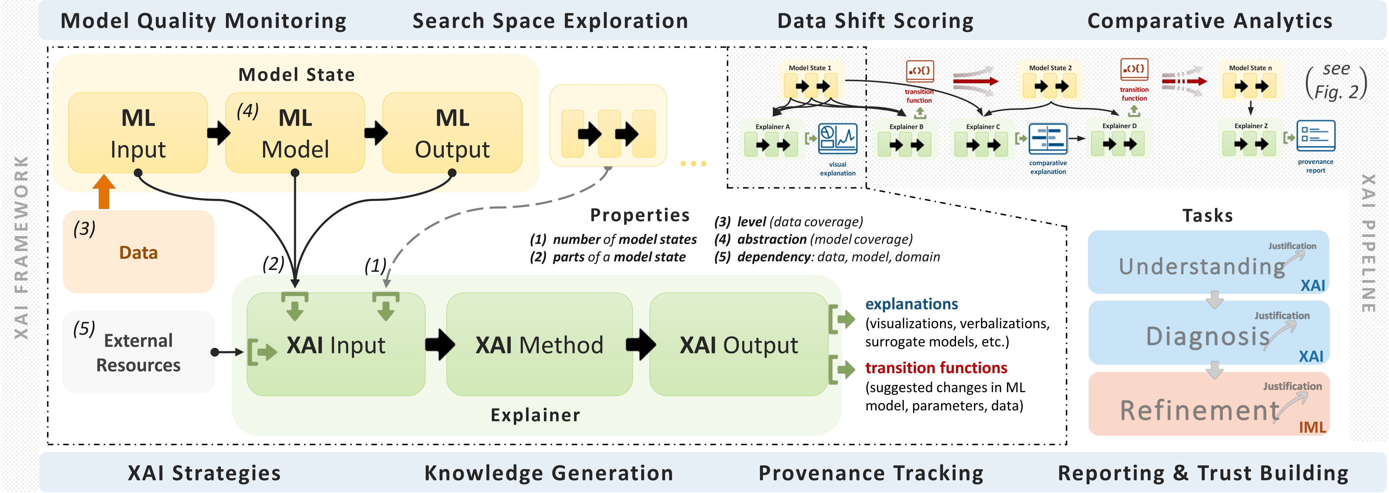

XAI framework diagram from explAIner

Microsoft Azure’s machine learning explainer is a built-in functionality inside Azure Machine Learning Studio, where it can either be used as a standalone module or submodule of their Automated ML tool. The team is able to learn how an explainer should explain models concisely from Azure’s machine learning explainer.

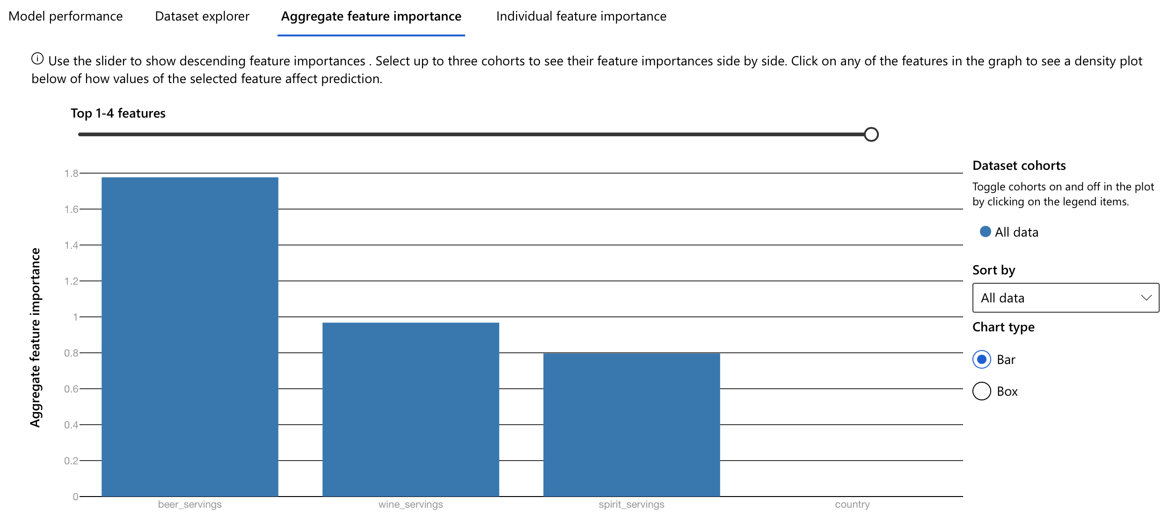

Explainer module explaining a model’s prediction bias

The solution the team came up with is an online explainer application that meets all of the primary goals, costing less than $100 a month to maintain. It is hosted on Microsoft Azure’s virtual machine, web application, and database services. In its core, it uses the same backend SDK as Microsoft Azure’s own explainer – the Interpret Community SDK, while its frontend websites are built with design and template tools like Anvil, Django, and Bootstrap.

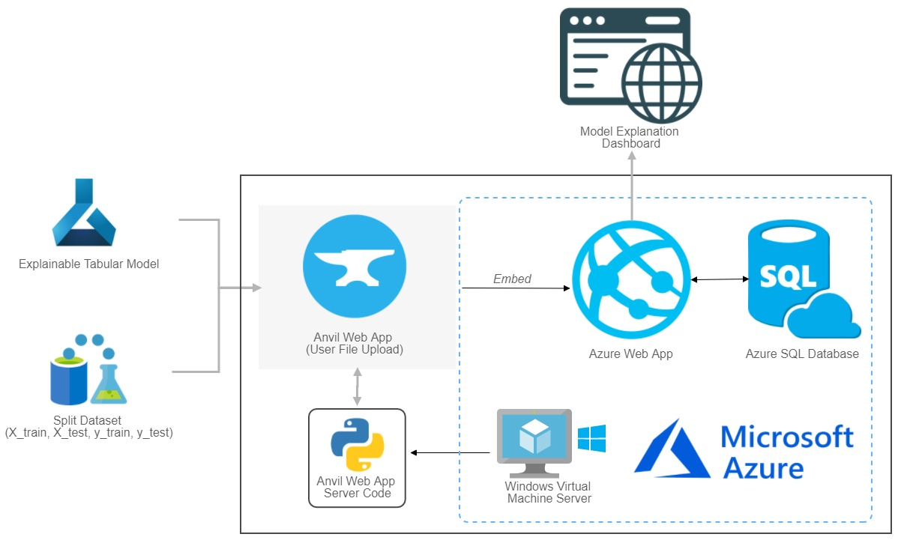

VizAI’s system architecture diagram

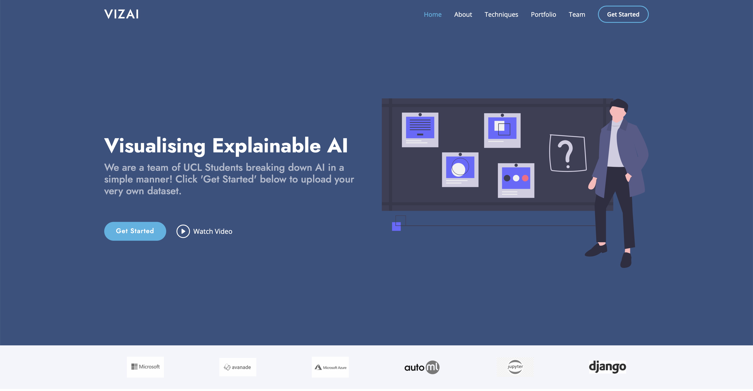

Prototype website

The most important technologies and libraries used in this project are the Microsoft Azure service and the open-source SHAP explainer.

Microsoft Azure is responsible for hosting Both the frontend websites and backend explainer modules. Its tight integration with Azure’s SQL database service also means data storage can be easily dealt with by connecting the services together.

The SHAP explainer module is an explainer based on Game Theory. It estimates the Shapely Value for every data point and assigns each feature as a player, then attempts to distribute the summation of predictions across all players to show how much each feature contributed to the overall prediction. This made it particularly strong in explaining the most popular machine learning models such as Deep Neural Networks, tree-based models, and linear regression models.

In the process of building the prototype, the team also utilized GitHub Action’s CI feature, creating a pipeline for building and testing the application. Once in place, the team no longer needs to manually test and build every new feature, saving precious time for the team.

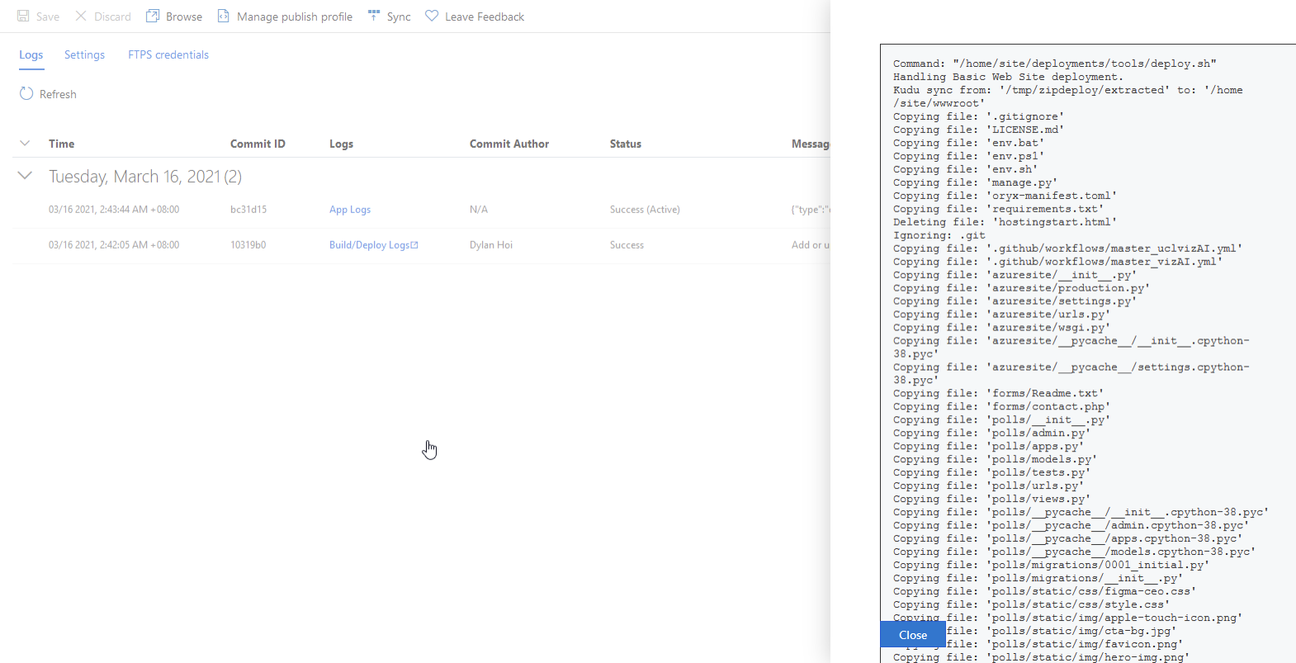

GitHub Action’s CI feature in action

The team has compiled a list of Learning Points from this project:

* Observe carefully. There may not be similar examples to reference, but precious knowledge can still be learned by studying individual parts of various loosely related projects.
* Don’t reinvent the wheel. Using reliable pre-built tools and libraries can be both faster and more economic.
* Communication is the key. With good communication through every stage of development, the workload can be distributed more evenly and progresses made faster.

Future works on the project include developing more in-depth functions for more technically advanced users and upgrading the system backend to handle more robust machine learning models. The team aims to continue the development of the web application and welcomes anyone willing to contribute to making explainable AI easier and faster.

GitHub link: https://github.com/deCourier/vizAI.git